Lab: State Management & Asynchronous Programming

This document defines the lab problems for the ["ASP.NET Fundamentals" Course @ SoftUni](https://softuni.bg/trainings/4105/asp-net-fundamentals-may-2023).

# State Management

## Examine Your Cookies

Most cookies are stored in a RDBMS, usually SQLite. You can download SQLite browser from [here](https://sqlitebrowser.org/). The location of the Mozilla cookies is the following:

**C:\Users\{username}\AppData\Roaming\Mozilla\Firefox\Profiles\{name}.default\cookies.sq lite**

The location of the Chrome cookies is the following: **C:\Users\{username}\AppData\Local\Google\Chrome\User Data\Default\Cookies** Open the file with the **SQLite** browser and explore your cookies.

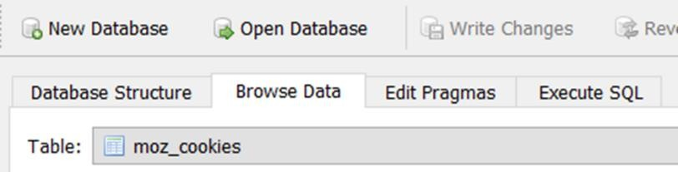

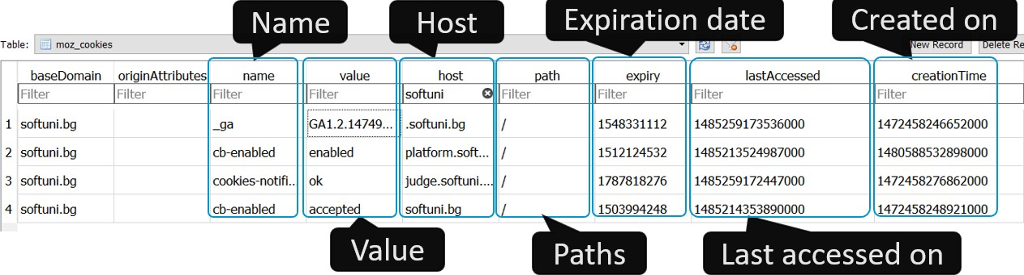

## Control Your Cookies (Mozilla)

Use Mozilla Browser to explore and control your cookies. Open the hamburger menu button and select **Settings:**

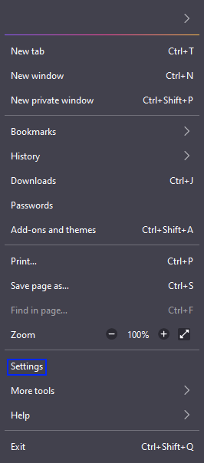

Select **Privacy & Security** and click on the **[Manage Data]** button:

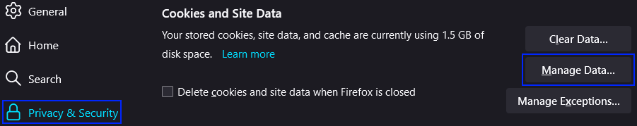

Type **softuni** in the **Search** bar and browse the cookies from the selected website. You can also delete a particular cookie or all of the cookies.

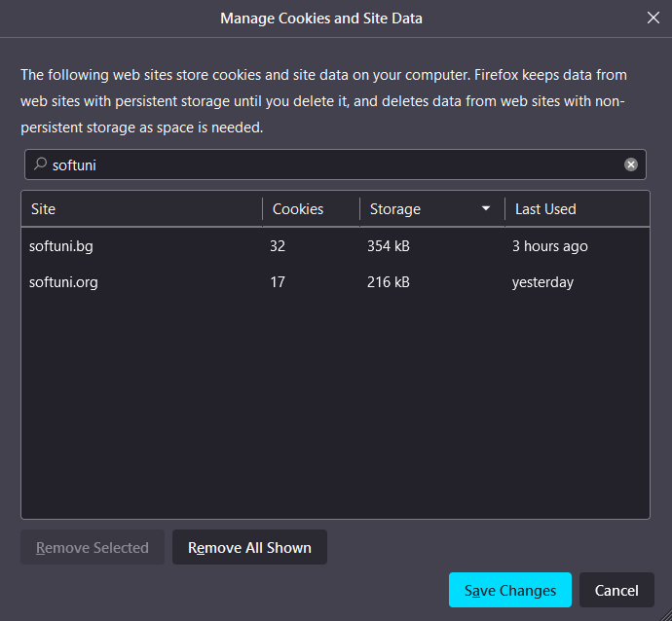

## Control Your Cookies (Chrome)

Use Chrome Browser to explore and control your cookies. Open the Kebab menu buttonand select **Settings:**

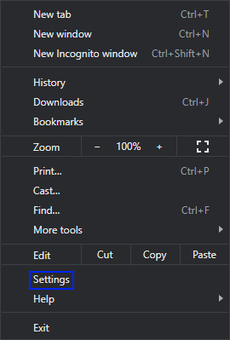

Go to **Privacy and security** and select **Cookies and other site data:**

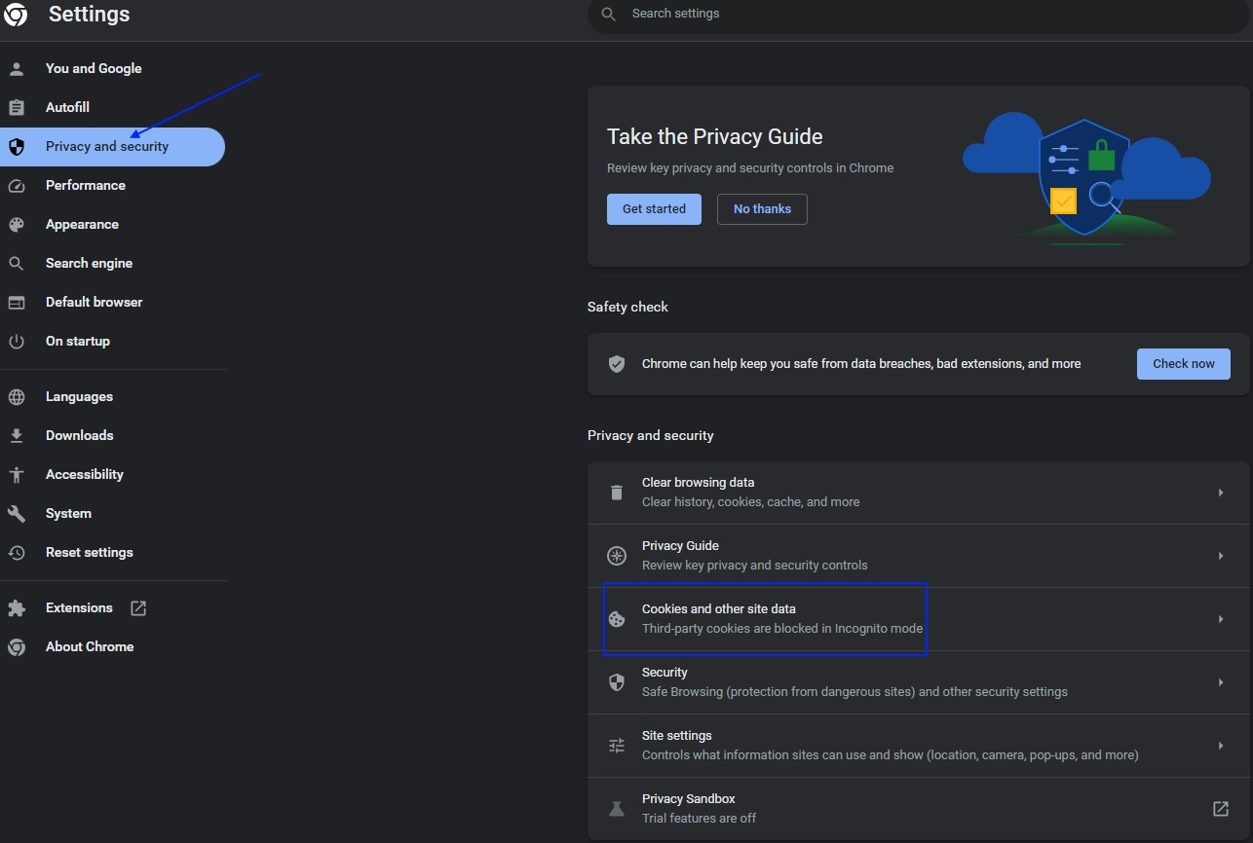

On the next window, click on **See all site data and permissions**. A new window opens with all of the websites that you have visited and their cookies, where you can browse the cookies.

You can also delete some of the cookies.

## Change Cookie

Go to [Amazon](https://www.amazon.com/) and look at the **menu language**.

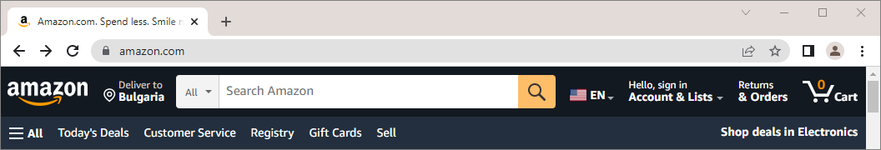

Open **DevTools** or press **F12** → **[Application]** and search for the language cookie:

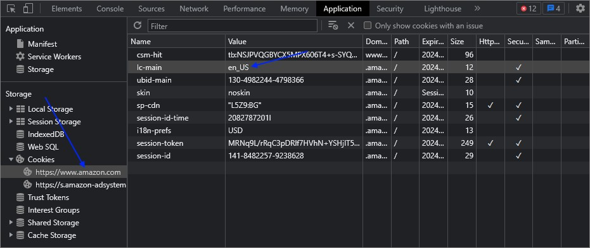

Change the cookie value to "**de_DE**" in order to change the language of the app:

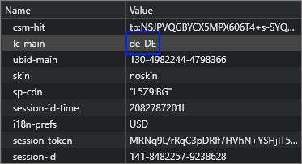

Refresh the site – it should be in **German** now:

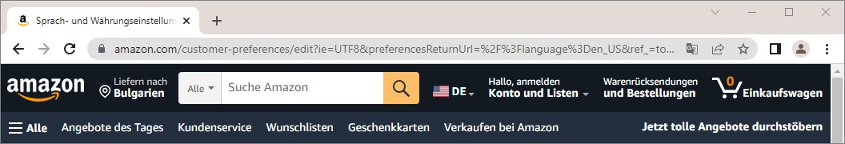

## Authentication with Cookies

Go to the [SoftUni Judge](https://judge.softuni.org/) site and log in. Search for the **authentication** cookie in the **Cookies** menu:

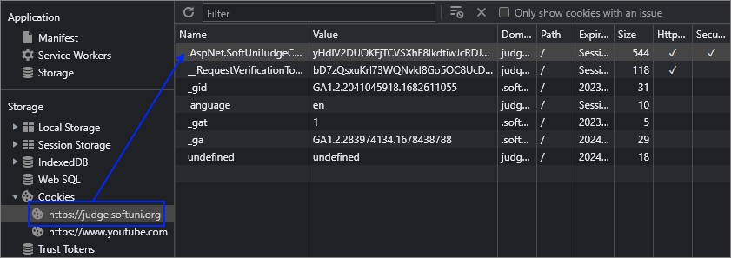

**Delete** the **authentication cookie. Refresh** Judge's site – you should **not** be logged-in **anymore**. The authentication cookie should be missing, too.

You can log in again – a new cookie should appear.

## Session

Go to the [GitHub](https://github.com/) site. Examine the **session cookie**, which holds the **current session id**.



**Close the browser** and visit the site again. Notice that now there is a new session with a **different ID**.



# Asynchronous Processing

## Even Numbers Thread

Print **all even** numbers in a given **range**. Printing should be executed on a **separate thread**. After all numbers are printed print "**Thread finished work**".

**Example**

|  |  |
| --- | --- |
| **Input** | **Output** |
| 1  10 | **2**  **4**  **6**  **8**  **10**  **Thread finished work** |

**Hint**

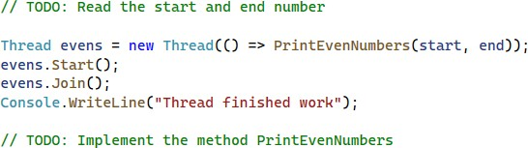

## Sum Evens in Range

Sum all even numbers in given range [**1** to **1000**]. Read commands and print the result only on command "**show**".

**Solution**

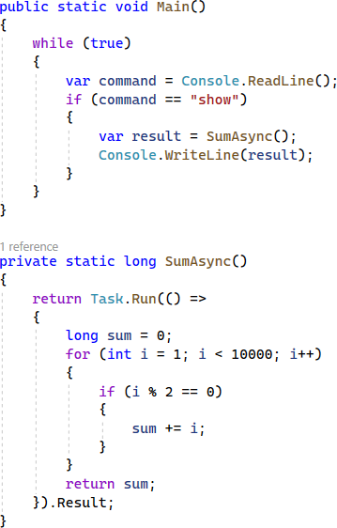

## Sum Evens in Background

This problem is similar to the previous one. You have to sum all even numbers in given range (**1** to **1000000000**), but this time leave the console interface unblocked while calculating the sum. Read commands and print the result only on command "**show**". Stop calculating on command "**exit**".

**Solution**

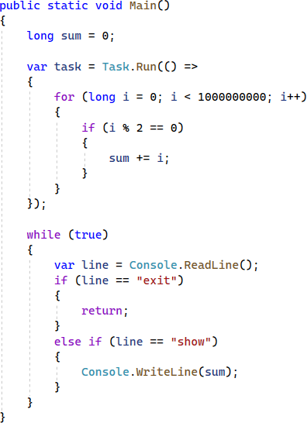

## Chronometer

The **Chronometer** is one of the easiest examples of an **asynchronous processes**. Let's implement a simple Chronometer.

Create an **interface IChronometer** like this:

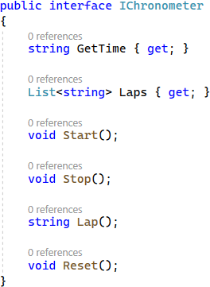

... and implement a class **Chronometer**, that implements it.

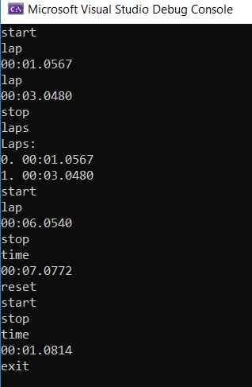

Implement a program which provides a **Chronometer functionality**, that responds to several commands from the user input:

* + **start** – starts counting time in milliseconds, seconds and minutes
  + **stop** – stops the process of counting time, but the counted time remains
  + **lap** – creates a lap at the current time
  + **laps** – returns all of the currently recorded laps
  + **time** – returns the currently recorded time
  + **reset** – stops the Chronometer, resets the currently recorded time and deletes all of the currently recoded laps
  + **exit** – stops and exits the program

Here is an example screenshot of the functionality:

The time is outputted in the following format: "**{minutes}:{seconds}:{milliseconds}**", each of them should be **padded** with **zeros**.

Upon **making** a **lap** you should print the **time** at which it was made. Requesting **all laps** should print them in the following format:

**Laps:**

1. **{lap1}**
2. **{lap2}**

**...**

In case there are no laps, you should print "**Laps: no laps**".

**Hints**

Let's start implementing our **asynchronous chronometer**. First, we need to create the **Chronometer class**, which implements the **IChronometer interface**:



Use the **Stopwatch C# class**, which provides a **set of methods and properties** that you can use to accurately measure elapsed **time**. Create a **field** for the stopwatch. Also, create a **collection for the laps**. Initialize the **fields** in the **constructor** like this:

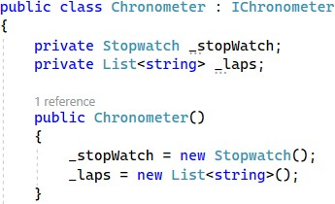

We have the **GetTime property**, which should return the **currently recorded time** since the start of the chronometer counter. Use the **Elapsed property** of the **Stopwatch class** to **get the total elapsed time**. This property returns the time as a **TimeSpan**, so you should convert it to **string** in the **correct format**. Do it like this:



The other property we have is the **Laps property**. It should just **return the current laps collection**:



Next, we should **implement** the **Start()** and **Stop() methods** of the **Chronometer class**. The **Stopwatch class**

has its own **methods for starting and stopping** – use them as shown below:

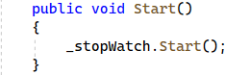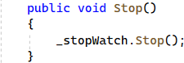

The **Lap() method** returns the **current elapsed time** as a **string** and **adds it to a collection of laps**. It uses the

**GetTime property**:

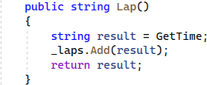

Finally, we have the **Reset() method**, which should **invoke the Reset() method** of the **Stopwatch class** and

**clear the laps collection**. Do it like this:

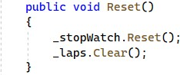

As we already have the **Chronometer class** let's use it and invoke its methods depending on **commands** from the console. **Instantiate the chronometer** in the **Main() method** of a **class** called **StartUp**:

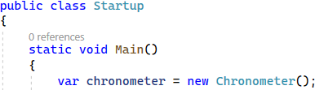

Then, we will **read a command** from the console, until the "**exit**" **command**.

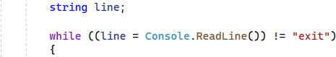

In the **while loop**, work with the chronometer depending on the **read command**. Don't forget that the **Start() command** of the **Chronometer class** should be **run as a task to be asynchronous**. After the **while loop** you should **stop the chronometer**. Complete the **Startup class** like this:

